Solution: Introduction to Locations

In this lab, you will configure various widgets to make navigable links. In the first part of this exercise, you will link the employer name in ABContactDetailsPersonDV to the contact details page for the employer. In the second part of this exercise, you will link the employee name in ABCompanyEmployeesLV to the contact details page for the employee.

Requirements

This lab requires that you use TrainingApp 8.0, Guidewire Studio 8.0, and a supported web browser. To view, edit, and delete various contacts, log in to TrainingApp as Alice Applegate. The default URL for TrainingApp is <http://localhost:8880/ab/ContactManager.do>. The login/password for Alice Applegate is aapplegate/gw.

1. Configure navigable links

Part A

In ABContactDetailsPersonDV, in Employment Info, there is the Employer widget. Currently, there is no navigable link for the Employer widget to the employer contact. A user would need to search for the Albertson's contact. In this part of the exercise, you will link the employer name on ABContactDetailsPersonDV to the employer contact details page.

Tasks

1. Modify the Employer widget to link to the employer's Details page.

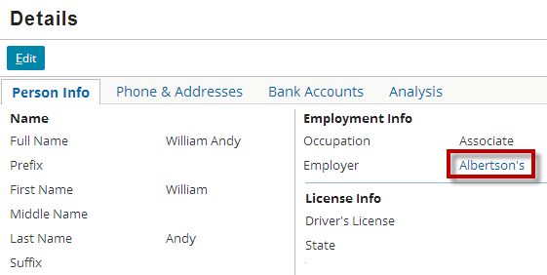

Note: If the person does not have an associated employer, there is not a visible link, but the widget is clickable. If you click on the empty link for a person that has no employer, TrainingApp will throw null pointer exception. Later in this lesson, you will modify the behavior of the input widget in order to disable the empty link.

Part B

In ABContactDetailsCompanyDV, in Employee info, there is the ABCompanyEmployeesLV. The list view panel shows all the employee contacts associated with the employer. Currently, there is no navigable link for the employee name in the list view panel to the employee contact. A user would need to search for the specific employee contact.

In this part of the exercise, you will link the employee name in the ABCompanyEmployeesLV to the employee contact details page.

Tasks

1. Modify the list view panel so that each employee name links to the contact details page.

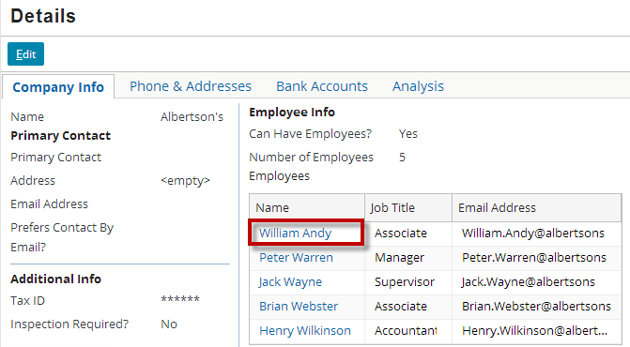

Verification

1. Log in to TrainingApp
2. Log in as Alice Applegate.
3. Reload the PCF changes
4. In TrainingApp, reload the changes to the PCF file(s).
5. Make associations between Person contacts and Company contact
6. Edit the employer field for various person contacts.
7. View the Details page for Person contacts
8. For your modified contacts, visit the details page.
9. Confirm that you are able to click a navigable link to the listed employer contact.
10. View the Details page for Company contact
11. Confirm that you are able to click a navigable link for each employee contact.
12. Configure widget property expressions

In the previous exercise, you modified the Employer widget in ABContactDetailsPersonDV to link to the employer's Details page. However, if you click on the empty link for a person that has no employer, TrainingApp will throw null pointer exception.

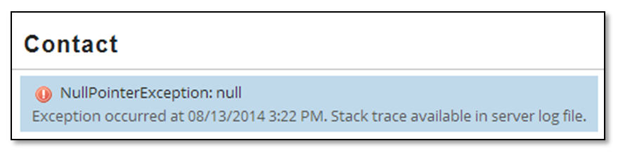

In this exercise, you will configure the Employer widget to so that if the person does not have an associated employer, the widget is not clickable.

Investigation

1. View the current widget behavior
2. In Guidewire Studio, debug the server.
3. In TrainingApp, search for a contact with an employer, for example, William Andy.
4. In the side bar menu, select Details.
5. Verify the Employer Link.
6. Click Edit.
7. Change the Employer to <none>.
8. Click Update.
9. Verify that presence of a link when the Employer field is null.
10. Click the link and verify the thrown exception.
11. Open the PCF to configure in Guidewire Studio
12. To open the PCF, use ALT+SHIFT+E.

Configuration

1. Modify the Employer widget
2. In the ABContactDetailsPersonDV.pcf file, modify the Employer widget.
3. Modify the action property expression so there is only an action when an Employer is specified for the Employer field.

Verification

1. Verify the modified widget behavior
2. In TrainingApp, deploy your changes to the PCF file.
3. Search for a contact with an employer, for example, William Andy.
4. In the side bar menu, select Details.
5. Verify that the there is no longer a link.
6. Click Edit.
7. Change the Employer to AB Construction.
8. Click Update.
9. Verify that presence of a link when the Employer field.

|  |  |
| --- | --- |
|  | Stop and ask your instructor to review your completed lab. |